FOR IMMEDIATE RELEASE
April 3, 2017
Contact: Richard Halsey, California Chaparral Institute, (760) 822-0029
Jeff Kuyper, Los Padres ForestWatch, (805) 617-4610 x1
Nina Robertson, Earthrise Law Center, (847) 636-1486

LAWSUIT PROMPTS US FOREST SERVICE TO CANCEL CONTROVERSIAL FUEL BREAK
THAT THREATENED FRAGILE HABITAT IN SANTA BARBARA COUNTY

Santa Barbara, Calif. – Today, two conservation organizations and the US Forest Service agreed to drop pending legal action in U.S. District Court concerning a controversial vegetation clearance project after forest officials formally withdrew the project’s approval. The groups – California Chaparral Institute and Los Padres ForestWatch – filed the lawsuit to protect fragile habitat and rare species in the path of a remote fuel break along the Gaviota Coast and to encourage a greater focus on reducing fire risk where it matters most: directly in and around communities.

The Gaviota Fuel Break would have clear-cut native chaparral habitat across a six-mile-long, 300-foot-wide swath (the length of a football field) between Refugio Pass and Gaviota Peak, along the crest of the Santa Ynez Mountains in the Los Padres National Forest. The site – located far away from any structures – lies at the heart of the Gaviota Coast, one of the crown jewels of Santa Barbara County.

The key species at risk is the beautiful Refugio manzanita (Arctostaphylos refugioensis). Considered “endangered” by the California Native Plant Society, this classic icon of the chaparral only grows in a narrow ridgeline band between Point Conception and Santa Ynez Peak along the coast of Santa Barbara County – exactly where the Gaviota Fuel Break was scheduled to run.

By filing the lawsuit last December, the groups hoped to protect Refugio manzanitas and other rare plants and animals in the path of the fuel break. The suit was also aimed at encouraging forest officials to focus their limited resources on reducing fire risk directly in and around communities.

The vast majority of fire ecologists agree that the best way to protect communities from wildfire is to create defensible space immediately around homes, and to retrofit structures with ignition-resistant building materials like fire-rated roofs, dual-paned glass, and screening. Clearing vegetation in remote areas, far away from structures, is a costly and often ineffective way to stop wildfires and protect homes.

“We are extremely grateful the Los Padres National Forest reconsidered this project,” said Richard Halsey, Director of the California Chaparral Institute. “We’re hopeful this decision signals greater agency collaboration with the both fire scientists and conservationists so we can work together to jointly develop effective plans to reduce fire risk to protect people and nature.”

“We appreciate the Forest Service’s decision to reconsider this project,” said ForestWatch executive director Jeff Kuyper. “We stand ready to assist forest officials in identifying and implementing proven, cost-effective, and environmentally sustainable ways to directly protect homes from wildfire.”
The groups were represented by Earthrise Law Center, the environmental law clinic at Lewis & Clark Law School – one of the top environmental law programs in the country.

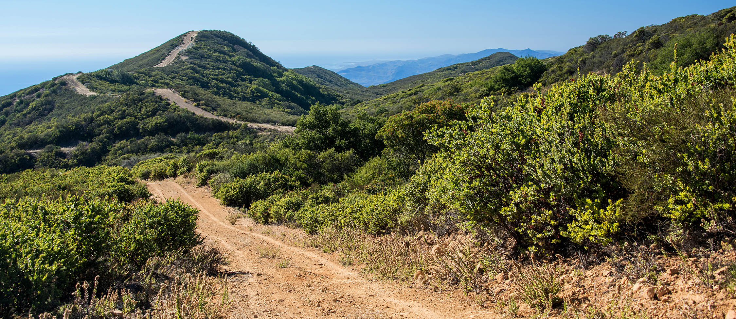

Photo: The ridgeline where the fragile chaparral habitat was scheduled to be clear cut, 150 feet on either side of the trail (the length of a football field). Refugio manzanita can be seen on the right.

California Chaparral Institute is a nonprofit, research, and educational organization dedicated to the preservation of native shrubland habitats throughout the world, with a particular focus on chaparral ecosystems in California.

Los Padres ForestWatch is the only local nonprofit organization working to protect wildlife, wilderness, and watersheds throughout the Los Padres National Forest, from the Big Sur Coast to the backcountry of San Luis Obispo, Santa Barbara, and Ventura counties and beyond.

Founded in 1996, Earthrise Law Center is the environmental legal clinic at Lewis & Clark Law School in Portland, Oregon with an office in San Francisco. Earthrise Law Center is a team of attorneys and staff working to achieve targeted environmental improvement while teaching the next generation of advocates to do the same.

